**Global Navigation Satellite System (GNSS) Radio Occultation Sounder Data Independent Exchange Format**

**Version 1.00**

National Space Science Center, CAS

E-mail：xgmeng@nssc.ac.cn

Jun., 2021

Table of contents

0 FORWARD 1

1 Scope 1

2 definitions, and abbreviations 1

2.1 Time 1

2.1.1 GPS time 1

2.1.2 BeiDou time 2

2.1.3 GLONASS time 2

2.1.3 Galileo System Time 2

2.1.4 QZSS Time 2

2.1.5 NavIC/IRNSS System Time 2

2.1.5 Time System Conversions 2

2.2 GNSS Radio Occultation 3

2.3 Carrier Phase Observation 3

2.4 Signal-to-Noise Ratio 3

2.5 Close-loop 3

2.6 Open-loop 3

2.7 Open-loop Model Phase 3

2.8 Abbreviations 4

3 General Concept 4

3.1 GNSS Occultation Sounder Data Independent Exchange Format File 4

3.1.1 Document type 4

3.1.2 Document naming 5

3.1.3 Document structure 6

3.1.4 Format description method 6

3.2 Document Header Section 6

3.2.1 Basic format 6

3.2.2 Arrangement order of header records 7

3.2.3 Handling of unknown items of header record information 7

3.2.4 Time system identification 7

3.3 Data Section 7

3.3.1 Recording rules of observation data 7

4 GNSS ATMOSPHERIC OCCULTATION OBSERVATION DATA INDEPENDENT EXCHANGE FORMAT FILE 8

4.1 Overview 8

4.2 Document Header Section 8

4.2.1 Components 8

4.2.2 Observation Code 9

4.2.3 Format of the Header Section 13

4.3 Data Section 15

4.3.1 Components 15

4.3.2 Observation time 16

4.3.3 Type of observations 16

4.3.4 Order of observations 17

4.3.5 Definition of the data section format 17

4.3.6 Epoch symbols of the data section 18

5 GNSS IONOSPHERIC OCCULTATION OBSERVATION DATA INDEPENDENT EXCHANGE FORMAT FILE 18

5.1 Overview 19

5.2 Document Header Section 19

5.2.1 Components 19

5.2.2 Observation Code 19

5.2.3 Format of the Header Section 19

5.3 Data Section 21

5.3.1 Components 21

5.3.2 Observation time of the data section 21

5.3.3 Type of observations 22

5.3.4 Order of Observations 22

5.3.5 Format of the data section 22

6 GNSS POSITIONING OBSERVATION DATA INDEPENDENT EXCHANGE FORMAT FILE 23

7 APPENDIX(informativ) 23

A.1 Example of BDS atmospheric occultation observation data file 23

A.2 Example of GPS atmospheric occultation observation data file 23

A.3 Example of BDS/GPS hybrid atmospheric occultation observation data file 23

A.4 Example of BDS ionospheric occultation observation data file 23

A.5 Example of GPS ionospheric occultation observation data file 23

# 0 FORWARD

This document is based on the actual needs of GNSS radio occultation detection applications. It refers to the organizational structure and data record formats of standard data formats, such as the Receiver Independent Exchange Format (RINEX) V4.00, developed jointly by the International GNSS Service (IGS), the Radio Technical Commission for Maritime Service (RTCM), and the International Association of Geodesy (IAG). This document modifies and extends these standards to accommodate the unique characteristics of GNSS occultation observation data, and designs the GNSS Radio Occultation Data Independent Exchange Format (ROEX). Additionally, it prepares and establishes standard files of GNSS radio occultation data independent exchange format, supporting the independent exchange and unified processing of GNSS radio occultation sounder data.

# Scope

This document specifies the type of Global Satellite Navigation System (GNSS) radio occultation sounder data independent exchange format file, composition structure, observation, and format of data records.

This document applies to the independent exchange of space-based global satellite navigation system radio occultation sounder (GNSS occultation sounder) data but also applies to the independent exchange of space-based regional satellite navigation system radio occultation sounder data. Mountain-based and air-based can be used for reference.

# definitions, and abbreviations

Before providing a detailed introduction to the ROEX format, we need to explain some basic definitions and abbreviations

## 2.1 Time

The time of the measurement is the receiver time of the received signals. In the observation data file of a multi-GNSS system combination, the header record must include a time system identifier to specify the time system used for all time-related tags (or time parameters) in the file.

### 2.1.1 GPS time

GPS Time (GPST) is a continuous time scale (no leap seconds) defined by the GPS Control segment on the basis of a set of atomic clocks at the Monitor Stations and onboard the satellites. It starts at 0h UTC (midnight) of January 5th to 6th 1980 (6.d0). At that epoch, the difference TAI−UTC was 19 seconds, thence GPS−UTC=n − 19s. GPS time is synchronized with the UTC(USNO) at 1 microsecond level (modulo one second), but actually is kept within 25 ns.

### 2.1.2 BeiDou time

BeiDou Time (BDT) is a continuous time scale starting at 0h UTC on January 1st, 2006. In order to be as consistent as possible with UTC, BDT may steer to an interposed frequency adjustment after a period of time (more than 30 days) according to the situation, but the quantity of adjustment is not to allowed more than .

### 2.1.3 GLONASS time

GLONASS Time (GLO) is basically running on UTC (or, more precisely, GLONASS system time linked to UTC(SU)), i.e. the time tags are given in UTC and not GPS time. It is not a continuous time, i.e. it introduces the same leap seconds as UTC.

### 2.1.3 Galileo System Time

Galileo System Time (GAL) is a continuous time scale maintained by the Galileo Central Segment and synchronized with TAI with a nominal offset below 50 ns.

The GST start epoch is 00:00 UT on Sunday 22nd August 1999 (midnight between 21st and 22nd August). At the start epoch, GST was ahead of UTC by 13 leap seconds. Since then, 3 additional leap seconds have been introduced (31 Dec. 2005 and 2008, and 30 Jun. 2012). Therefore, currently GST is ahead of UTC by 16 seconds.

### 2.1.4 QZSS Time

QZSS runs on QZSS time, which conforms to UTC Japan Standard Time Group (JSTG) time and the offset with respect to GPS time is controlled. The following properties apply to the QZSS time definition: the length of one second is defined with respect to TAI; QZSS time is aligned with GPS time (offset from TAI by integer seconds).

### 2.1.5 NavIC/IRNSS System Time

NavIC/IRNSS runs on Indian Regional Navigation Satellite System Time (IRNSST). The IRNSST start epoch is 00:00:00 on Sunday August 22nd, 1999, which corresponds to August 21st, 1999, 23:59:47 UTC.

### 2.1.5 Time System Conversions

If the small deviation between time systems is ignored, GLO can take the same value as UTC in the data file, and the relationship between UTC and GPS, GAL, BDT, QZS, and IRN can be expressed by equations (1) to (5):

where:

—— Leap second correction between GPS time and UTC given in the GPS navigation message;

—— Leap second correction between GAL time and UTC given in Galileo navigation messages;

—— Leap second correction between BDT time and UTC given in BDS navigation messages;

—— Leap second correction between QZS time and UTC given in QZSS navigation messages;

—— Leap second correction between IRN time and UTC given in IRNSS navigation messages.

## 2.2 GNSS Radio Occultation

Limb detection of GNSS satellites by the GNSS Occultation Sounder. GNSS radio occultation events occur when the GNSS occultation sounder tracks GNSS satellites as the signal path rises or falls through the Earth's atmosphere and ionosphere.

**Note 1**: By analyzing the phase and amplitude of the occultation signal of the tracked GNSS satellite recorded by the GNSS occultation sounder, the refractive index, density, air pressure, temperature, humidity of the atmosphere, and the refractive index and electron density of the ionosphere and other elements can be obtained.

**Note 2**: GNSS occultation detectors can be placed on platforms such as satellite platforms, mountaintops, aircraft, or floatplanes.

## 2.3 Carrier Phase Observation

The cumulative phase of the GNSS signal carrier is measured by the GNSS occultation sounder tracking the carrier signal.

**Note**: Locked signal during positioning observation, occultation closed-loop observation, unlocked signal during occultation open-loop observation (ground reconstruction of carrier phase observation).

## 2.4 Signal-to-Noise Ratio

The ratio of the average power of the signal observed by the GNSS occultation sounder to the average power of the noise.

## 2.5 Close-loop

Tracking loop with feedback system, the feedback system uses the local signal and the real received signal carrier phase and pseudorange difference to calculate the signal frequency and phase, feedback control of the local pseudo-code, and carrier CNC oscillator to generate the local pseudo-codes and carriers.

## 2.6 Open-loop

Calculate local carrier and pseudo-code phases using dynamics and atmospheric models, and control local pseudo-code and carrier CNC oscillators to generate local pseudo-codes and carriers.

## 2.7 Open-loop Model Phase

Predicted carrier phase (and pseudo-code phase) for GNSS occultation open-loop tracking using dynamical and atmospheric models, combined with GNSS satellite and GNSS occultation sounder position velocities.

## 2.8 Abbreviations

The following abbreviations are applicable to this document.

**ASCII**: American Standard Code for Information Interchange

**BDS**: BeiDou Navigation Satellite System

**Galileo**: Galileo Navigation Satellite System

**GLONASS**: Global Navigation Satellite System

**GNSS**: Global Navigation Satellite System

**GPS**: Global Positioning System

**IQ**: In-phase and Quadrature

**IRNSS**: Indian Regional Navigation Satellite System

**ITRF**: International Terrestrial Reference Frame

**LEO**: Low Earth Orbit Satellite

**PRN**: Pseudo Random Noise

**QZSS**: Quasi-Zenith Satellite System

**RINEX**: Receiver Independent Exchange Format

**ROEX**: GNSS Radio Occultation Data Independent Exchange Format

**SBAS**: Satellite-Based Augmentation System

**SNR**: Signal-to-Noise Ratio

**UTC**: Coordinated Universal Time

**TAI**: International Atomic Time

# General Concept

## 3.1 GNSS Occultation Sounder Data Independent Exchange Format File

### 3.1.1 Document type

The GNSS occultation sounder data includes GNSS radio occultation observation data and positioning observation data. This document has developed a special ROEX format for GNSS radio occultation observation data for independent exchange of occultation observation data.

The GNSS occultation sounder data independent exchange format file is a pure ASCII text file, and the three file types included are as follows:

1. GNSS atmospheric occultation observation[1]) data files (including single-system and multi-system hybrid observation data files), which follow the ROEX atmospheric observation data file format;
2. GNSS ionospheric occultation observation data files, which follow the ROEX ionospheric observation data file format;
3. GNSS positioning observation data files (including single-system and multi-system hybrid observation data files), which follow the RINEX observation data file format

### 3.1.2 Document naming

GNSS radio occultation detector data independent exchange format file naming is recommended by the carrier name, sounder name, data start time, data duration, data type, and file suffix, etc., the format is as follows:

**Mission_Payload_StartTime_Duration _DataType.Format.Compression**

The character length of each field is fixed, separated by "_", and the last two fields "Format" and "Compression" are separated by "." between "Format" and "Compression". If the data length is insufficient, it is filled with 0. The description of each subparagraph in the file name is shown in Table 1.

**Note**: File naming is not strictly part of the GNSS occultation sounder data exchange format definition, users can follow only the ROEX and RINEX data format definitions according to business needs.

**Tab. 1** Description of each sub-item in the file naming

|  |  |  |  |
| --- | --- | --- | --- |
| **Description items** | **Name** | **Necessary** | **Format** |
| **Mission** | Name of the mission (or spacecraft) | Yes | 4-character marker  e.g.: FY3D means Fengyun-3D satellite |
| **Payload** | GNSS occultation sounder name | Yes | 4-character marker  e.g.: GNOS denotes the name of the GNSS occultation sounder on the FY3D satellite |
| **StartTime** | Data start time | Yes | Marked with 14 characters in the format YYYYMMDDHHMMSS, where YYYY means 4-digit year, MM means 2-digit month, DD means 2-digit day, and HHMMSS means the measurement start time (hour, minute, second).  e.g.: 20210408121121 means the data start time is 12:11:21 on April 8, 2021.  Time system using the file header identification of the time system |
| **Duration** | Data duration | Yes | 5-characters marker, unit in seconds  Padding with zeros on the left side of the insufficient part  e.g.: 00090 means the data duration is 90 seconds |
| **DataType** | Data Type | Yes | Mark with 2 characters in the format SF  S: Satellite System Identifier  F: Data types (A: atmospheric occultation observations; I: ionospheric occultation observations; P: positioning observations)  details:  CA=BDS Atm. Obs.  GA=GPS Atm. Obs.  RA=GLONASS Atm. Obs.  EA=Galileo Atm. Obs.  JA=QZSS Atm. Obs.  SA=SBAS Atm. Obs.  IA=IRNSS Atm. Obs.  MA=Mixed Atm. Obs.  CI=BDS Ion. Obs.  GI=GPS Ion. Obs.  RI=GLONASS Ion. Obs.  EI=Galileo Ion. Obs.  JI=QZSS Ion. Obs.  SI=SBAS Ion. Obs.  II=IRNSS Ion. Obs.  CP=BDS Pos. Obs.  GP=GPS Pos. Obs.  RP=GLONASS Pos. Obs.  EP=Galileo Pos. Obs.  JP=QZSS Pos. Obs.  SP=SBAS Pos. Obs.  IP=IRNSS Pos. Obs.  MP=Mixed Pos. Obs.  Where, Atm. Obs.: Atmospheric Observation; Ion. Obs.: Ionospheric Observation; Pos. Obs.: Positioning Observation. |
| **Format** | Data file format | Yes | 3-character marker, ROX (or rox) if in ROEX format, RNX (or rnx) if in RINEX format. |
| **Compression** | Compression method for data files | No | 2-3-character markers  e.g.: gz: gzip compression method; zip: bzip2 compression method. |

### 3.1.3 Document structure

Each type of GNSS occultation sounder data independent exchange format file consists of a "header" section, which is a description of the file and data record, and a "data" section, which is used to record the observation data.

### 3.1.4 Format description method

GNSS occultation sounder data independent exchange format file, the format of each line is expressed as oZa.b. When the data type is X, A, I, the data has only oZa part, and when the data type is F, only a.b part. Where:

1. o: the total amount of data of the same type and format, if default it means only 1 data; if "m" means there are m data;
2. Z: the data type:

1) X: Any placeholder character (space or non-valid character for additional description);

2) A: Valid characters;

3) F: Floating type numbers;

4) I: Integer type number.

1. a.b: The length of the data, where:

1) a: Total length of data bits (all valid digits including decimal points);

2) b: Decimal part length (number of valid digits after the decimal point).

**Example**:

-  **2F8.3:** two consecutive floating-point numbers, each occupying a total of 8 digits, with the decimal part being 3 digits.

## 3.2 Document Header Section

### 3.2.1 Basic format

Each line of the header section of the GNSS occultation sounder data independent exchange format file is a header record. The length of each header record is no more than 80 ASCII characters (columns), of which, 1~60 columns are the information part of the header record, and 61~80 columns are the header record identification. The header record identifier has a uniformly specified format and is a description of the content of the information portion of columns 1~60 of the row.

The ROEX file header section contains a description of the global attributes in the mask data file and a list of observation codes.

### 3.2.2 Arrangement order of header records

The order of the header records in the ROEX format file can be freely arranged except for the following requirements, see Appendix A for an example. The two fixed header records are:

a) “ROEX VERSION/TYPE” should be the first header record in the document;

b) “END OF HEADER” is the last header record.

### 3.2.3 Handling of unknown items of header record information

When the GNSS occultation sounder data independent exchange format file is generated, unknown items in the header record information section may be zeroed or left blank, or the entire header record may be left blank. Until the value of the header record or item is obtained, the program that reads the OBS data SNF file may set the default header record or missing item to zero or blank.

### 3.2.4 Time system identification

The GNSS occultation sounder data independent exchange format file uses a three-character valid time system identifier to indicate the time system used in the file.

In the observation data file of a single satellite navigation system (BDS, GPS, GLONASS, Galileo, QZSS or IRNSS), the time system identifier is by default the time of that satellite navigation system, and the headers record "TIME OF FIRST OBS" (or "TIME OF FIRST CLO" or "TIME OF FIRST OPE") and "TIME OF LAST OBS" (or "TIME OF LAST CLO" or "TIME OF LAST OPE") may optionally contain the time system identifier; and in the case of BDS/GPS/GLONASS/Galileo/QZSS/ IRNSS multi-satellite navigation system combination observation data files, these two header records must contain the time system identifier, which identifies the time system used for all marked times (or time parameters) in the file.

The time system markers are defined as follows:

a) BDT: BDS Time;

b) GPS: GPS Time;

c) GLO: GLONASS Time;

d) GAL: Galileo Time;

e) QZS: QZSS Time;

f) IRN: IRNSS Time.

## 3.3 Data Section

### 3.3.1 Recording rules of observation data

The rules for recording the observation data are as follows:

1. The first line of each ephemeris record includes the observation time, the number of satellites, the receiver clock bias, and other information, starting with the symbol “>”;
2. Each (row) of observation data records below the epoch line starts with the satellite system and number *snn*, the specific identifier and number are defined in Table 2. the next row starts with the observation type and observation information of the same observation data record;
3. For atmospheric occultation observation data files, the signs "START OF OBS CLO" and "END OF OBS CLO" should be used to indicate the beginning and end of closed-loop observation records, and the signs "START OF OBS OPE" and "END OF OBS OPE" should be used to indicate the beginning and end of open-loop observation records, respectively;
4. For ionospheric occultation observation data files, the end-of-file marker "END OF HEADER" is immediately followed by the observation data record.

**Tab.2** Satellite system identifier and number definition

|  |  |  |
| --- | --- | --- |
| **Satellite Systems** | **System identifier (s)** | **Satellite number (nn)** |
| **BDS** | C | PRN code of the system's observed satellite |
| **GPS** | G |
| **Galileo** | E |
| **IRNSS** | I |
| **GLONASS** | R | The slot number of the frequency segment of the satellite system |
| **SBAS** | S | Its PRN code minus 100 (e.g., SBAS satellite PRN 120 is represented as S20) |
| **QZSS** | J | PRN code minus two digits of a fixed value |
| **Note**: For LEX/L6D of QZSS system with centimeter-level enhancement service, the fixed value is 192; for L1-SAIF/L1S with sub-meter-level enhancement service, the fixed value is 182; for L6E with centimeter-level enhancement experiment, the fixed value is 202; for L5S used for positioning technology verification, the snn and PRN codes correspond to: J02 (PRN196), J03 (PRN200), and J07 (PRN197). | | |

# GNSS ATMOSPHERIC OCCULTATION OBSERVATION DATA INDEPENDENT EXCHANGE FORMAT FILE

## 4.1 Overview

Each GNSS atmospheric occultation observation data file contains data for a single occultation event observation period only. The header section of the data file describes the global properties of that atmospheric occultation event, and the data section is the observation data record of that atmospheric occultation event.

## 4.2 Document Header Section

### 4.2.1 Components

The file header of GNSS atmospheric occultation observation data file consists of several header records from "REX VERSION/TYPE" to "END OF HEADER", and a typical file header composition is shown in Fig. 1.

The observation code in the header record is used to identify the type of observation in the data record in the data section, as defined in 4.2.2, and the correspondence with the observation is defined in 4.3.4. The specific format of the header record is defined in 4.3.5.

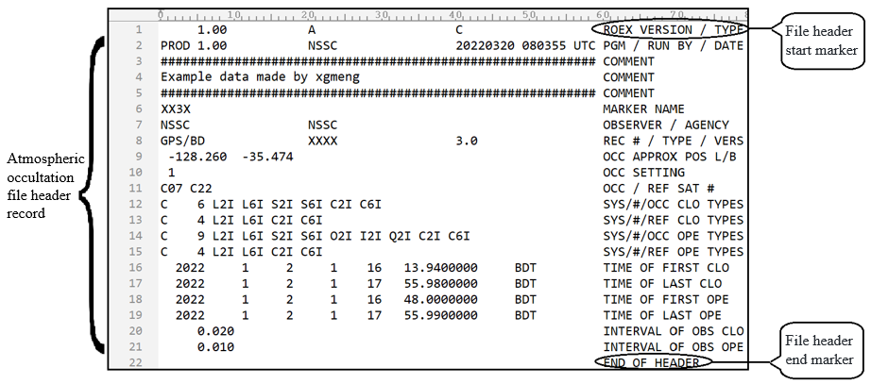

**Fig.1** The composition of the header section of a typical atmospheric occultation observation data file

### 4.2.2 Observation Code

The header section of the GNSS atmospheric occultation data file uses observation codes to identify the different observations and their attributes, the list of observation codes is shown in Table 3.:

a) t: the observation type:

1) L: Carrier phase;

2) S: Signal-to-noise ratio;

3) C: pseudo-range;

4) O: Open-loop model phase;

5) I: Open-loop I circuit;

6) Q: Open-loop Q circuit.

b) n: band/frequency with the value of 1, 2, …, 8;

c) a: Properties, the tracking mode or channel (e.g., I, Q, etc.). Observation code for a combined code (e.g. M+L) or combined channel (e.g. I+Q) tracking mode with the attribute identifier "X".

**Note**: I and Q in the observation type denote the isotropic and quadrature correlation results of the local signal in open-loop tracking, while I and Q in the attribute denote the isotropic and quadrature modulated components of the GNSS transmit signal.

**Tab. 3** Observation code

|  |  |  |  |  |  |  |  |  |  |  |  |  |  |
| --- | --- | --- | --- | --- | --- | --- | --- | --- | --- | --- | --- | --- | --- |
| **System** | **Frequency Band** | **Frequency MHz** | **Channel/Ranging Code** | **Observation code** | | | | | | | | | |
| **Carrier Phase** | | **Signal-to-noise ratio** | **pseudo-range** | | | **Open-loop model phase** | **Open-loop I circuit** | | **Open-loop Q circuit** |
| **BDS** | B1  (BDS-2/3 Signal) | 1561.098 | I (B1I Signal) | L2I | | S2I | C2I | | | O2I | I2I | | Q2I |
| Q | L2Q | | S2Q | C2Q | | | O2Q | I2Q | | Q2Q |
| I+Q | L2X | | S2X | C2X | | | O2X | I2X | | Q2X |
| B1C  (BDS-3 Signal) | 1575.42 | Data | L1D | | S1D | C1D | | | O1D | I1D | | Q1D |
| Pilot | L1P | | S1P | C1P | | | O1P | I1P | | Q1P |
| Data+Pilot | L1X | | S1X | C1X | | | O1X | I1X | | Q1X |
| B1A  (BDS-3 Signal) | 1575.42 | Data | L1S | | S1S | C1S | | | O1S | I1S | | Q1S |
| Pilot | L1L | | S1L | C1L | | | O1L | I1L | | Q1L |
| Data+Pilot | L1Z | | S1Z | C1Z | | | O1Z | I1Z | | Q1Z |
| B2a  (BDS-3 Signal) | 1176.45 | Data | L5D | | S5D | C5D | | | O5D | I5D | | Q5D |
| Pilot | L5P | | S5P | C5P | | | O5P | I5P | | Q5P |
| Data+Pilot | L5X | | S5X | C5X | | | O5X | I5X | | Q5X |
| B2  (BDS-2 Signal) | 1207.140 | I (B2I Signal) | L7I | | S7I | C7I | | | O7I | I7I | | Q7I |
| Q | L7Q | | S7Q | C7Q | | | O7Q | I7Q | | Q7Q |
| I+Q | L7X | | S7X | C7X | | | O7X | I7X | | Q7X |
| B2b  (BDS-3 Signal) | 1207.140 | Data | L7D | | S7D | C7D | | | O7D | I7D | | Q7D |
| Pilot | L7P | | S7P | C7P | | | O7P | I7P | | Q7P |
| Data+Pilot | L7Z | | S7Z | C7Z | | | O7Z | I7Z | | Q7Z |
| B2(B2a+B2b)  (BDS-3 Signal) | 1191.795 | Data | L8D | | S8D | C8D | | | O8D | I8D | | Q8D |
| Pilot | L8P | | S8P | C8P | | | O8P | I8P | | Q8P |
| Data+Pilot | L8X | | S8X | C8X | | | O8X | I8X | | Q8X |
| B3  (BDS-2/3 Signal) | 1268.52 | I | L6I | | S6I | C6I | | | O6I | I6I | | Q6I |
| Q | L6Q | | S6Q | C6Q | | | O6Q | I6Q | | Q6Q |
| I+Q | L6X | | S6X | C6X | | | O6X | I6X | | Q6X |
| B3A  (BDS-3 Signal) | 1268.52 | Data | L6D | | S6D | C6D | | | O6D | I6D | | Q6D |
| Pilot | L6P | | S6P | C6P | | | O6P | I6P | | Q6P |
| Data+Pilot | L6Z | | S6Z | C6Z | | | O6Z | I6Z | | Q6Z |
| **GPS** | L1 | 1575.42 | C/A | L1C | | S1C | C1C | | | O1C | I1C | | Q1C |
| L1C(D) | L1S | | S1S | C1S | | | O1S | I1S | | Q1S |
| L1C(P) | L1L | | S1L | C1L | | | O1L | I1L | | Q1L |
| L1C(D+P) | L1X | | S1X | C1X | | | O1X | I1X | | Q1X |
| P (AS invalid) | L1P | | S1P | C1P | | | — | — | | — |
| Z- Tracking and Similar Computing (AS valid) | L1W | | S1W | C1W | | | — | — | | — |
| Y | L1Y | | S1Y | C1Y | | | O1Y | I1Y | | Q1Y |
| M | L1M | | S1M | C1M | | | O1M | I1M | | Q1M |
| Uncoded | L1N | | S1N | — | | | — | — | | — |
| L2 | 1227.60 | C/A | L2C | | S2C | C2C | | | O2C | I2C | | Q2C |
| L1(C/A) +(P2-P1)  (Semi-Uncoded) | L2D | | S2D | C2D | | | O2D | I2D | | Q2D |
| L2C(M) | L2S | | S2S | C2S | | | O2S | I2S | | Q2S |
| L2C(L) | L2L | | S2L | C2L | | | O2L | I2L | | Q2L |
| L2C(M+L) | L2X | | S2X | C2X | | | O2X | I2X | | Q2X |
| P (AS invalid) | L2P | | S2P | C2P | | | — | — | | — |
| Z- Tracking and Similar Computing (AS valid) | L2W | | S2W | C2W | | | — | — | | — |
| Y | L2Y | | S2Y | C2Y | | | O2Y | I2Y | | Q2Y |
| M | L2M | | S2M | C2M | | | O2M | I2M | | Q2M |
| Uncoded | L2N | | S2N | — | | | — | — | | — |
| L5 | 1176.45 | I | L5I | | S5I | C5I | | | O5I | I5I | | Q5I |
| Q | L5Q | | S5Q | C5Q | | | O5Q | I5Q | | Q5Q |
| I+Q | L5X | | S5X | C5X | | | O5X | I5X | | Q5X |
| **GLONASS** | G1 | 1602+k×9/16(k= -7～+12) | C/A | | L1C | S1C | | C1C | O1C | | | I1C | Q1C |
| P | | L1P | S1P | | C1P | O1P | | | I1P | Q1P |
| G1a | 1600.995 | L1OCd | | L4A | S4A | | C4A | O4A | | | I4A | Q4A |
| L1OCp | | L4B | S4B | | C4B | O4B | | | I4B | Q4B |
| L1OCd+L1OCp | | L4X | S4X | | C4X | O4X | | | I4X | Q4X |
| G2 | 1246+k×  7/16 | C/A | | L2C | S2C | | C2C | O2C | | | I2C | Q2C |
| P | | L2P | S2P | | C2P | O2P | | | I2P | Q2P |
| G2a | 1248.06 | L2CSI | | L6A | S6A | | C6A | O6A | | | I6A | Q6A |
| L2OCp | | L6B | S6B | | C6B | O6B | | | I6B | Q6B |
| L2CSI+L2OCp | | L6X | S6X | | C6X | O6X | | | I6X | Q6X |
| G3 | 1202.025 | I | | L3I | S3I | | C3I | O3I | | | I3I | Q3I |
| Q | | L3Q | S3Q | | C3Q | O3Q | | | I3Q | Q3Q |
| I+Q | | L3X | S3X | | C3X | O3X | | | I3X | Q3X |
| **Galileo** | E1 | 1575.42 | A PRS | | L1A | S1A | | C1A | O1A | | | I1A | Q1A |
| B OS data | | L1B | S1B | | C1B | O1B | | | I1B | Q1B |
| C OS pilot | | L1C | S1C | | C1C | O1C | | | I1C | Q1C |
| B+C | | L1X | S1X | | C1X | O1X | | | I1X | Q1X |
| A+B+C | | L1Z | S1Z | | C1Z | O1Z | | | I1Z | Q1Z |
| E5a | 1176.45 | I F/NAV OS | | L5I | S5I | | C5I | O5I | | | I5I | Q5I |
| Q No Data | | L5Q | S5Q | | C5Q | O5Q | | | I5Q | Q5Q |
| I+Q | | L5X | S5X | | C5X | O5X | | | I5X | Q5X |
| E5b | 1207.140 | I I/NAV OS/CS/SoL | | L7I | S7I | | C7I | O7I | | | I7I | Q7I |
| Q No Data | | L7Q | S7Q | | C7Q | O7Q | | | I7Q | Q7Q |
| I+Q | | L7X | S7X | | C7X | O7X | | | I7X | Q7X |
| E5(E5a+E5b) | 1191.795 | I | | L8I | S8I | | C8I | O8I | | | I8I | Q8I |
| Q | | L8Q | S8Q | | C8Q | O8Q | | | I8Q | Q8Q |
| I+Q | | L8X | S8X | | C8X | O8X | | | I8X | Q8X |
| E6 | 1278.75 | A PRS | | L6A | S6A | | C6A | O6A | | | I6A | Q6A |
| B C/NAV CS | | L6B | S6B | | C6B | O6B | | | I6B | Q6B |
| C No Data | | L6C | S6C | | C6C | O6C | | | I6C | Q6C |
| B+C | | L6X | S6X | | C6X | O6X | | | I6X | Q6X |
| A+B+C | | L6Z | S6Z | | C6Z | O6Z | | | I6Z | Q6Z |
| **SBAS** | L1 | 1575.42 | C/A | | L1C | S1C | | C1C | O1C | | | I1C | Q1C |
| L5 | 1176.45 | I | | L5I | S5I | | C5I | O5I | | | I5I | Q5I |
| Q | | L5Q | S5Q | | C5Q | O5Q | | | I5Q | Q5Q |
| I+Q | | L5X | S5X | | C5X | O5X | | | I5X | Q5X |
| **QZSS** | L1 | 1575.42 | C/A | | L1C | S1C | | C1C | O1C | | | I1C | Q1C |
| C/B | | L1E | S1E | | C1E | O1E | | | I1E | Q1E |
| L1C(D) | | L1S | S1S | | C1S | O1S | | | I1S | Q1S |
| L1C(P) | | L1L | S1L | | C1L | O1L | | | I1L | Q1L |
| L1C(D+P) | | L1X | S1X | | C1X | O1X | | | I1X | Q1X |
| L1S/L1-SAIF | | L1Z | S1Z | | C1Z | O1Z | | | I1Z | Q1Z |
| L1Sb | | L1B | S1B | | C1B | O1B | | | I1B | Q1B |
| L2 | 1227.60 | L2C(M) | | L2S | S2S | | C2S | O2S | | | I2S | Q2S |
| L2C(L) | | L2L | S2L | | C2L | O2L | | | I2L | Q2L |
| L2C(M+L) | | L2X | S2X | | C2X | O2X | | | I2X | Q2X |
| L5 | 1176.45 | I | | L5I | S5I | | C5I | O5I | | | I5I | Q5I |
| Q | | L5Q | S5Q | | C5Q | O5Q | | | I5Q | Q5Q |
| I+Q | | L5X | S5X | | C5X | O5X | | | I5X | Q5X |
| L5S(I) | | L5D | S5D | | C5D | O5D | | | I5D | Q5D |
| L5S(Q) | | L5P | S5P | | C5P | O5P | | | I5P | Q5P |
| L5S(I+Q) | | L5Z | S5Z | | C5Z | O5Z | | | I5Z | Q5Z |
| L6 | 1278.75 | L6D | | L6S | S6S | | C6S | O6S | | | I6S | Q6S |
| L6P | | L6L | S6L | | C6L | O6L | | | I6L | Q6L |
| L6(D+P) | | L6X | S6X | | C6X | O6X | | | I6X | Q6X |
| L6E | | L6E | S6E | | C6E | O6E | | | I6E | Q6E |
| L6(D+E) | | L6Z | S6Z | | C6Z | O6Z | | | I6Z | Q6Z |
| **IRNSS** | L5 | 1176.45 | A SPS | | L5A | S5A | | C5A | O5A | | | I5A | Q5A |
| B RS(D) | | L5B | S5B | | C5B | O5B | | | I5B | Q5B |
| C RS(P) | | L5C | S5C | | C5C | OL5C | | | I5C | Q5C |
| B+C | | L5X | S5X | | C5X | O5X | | | I5X | Q5X |
| S | 2492.028 | A SPS | | L9A | S9A | | C9A | O9A | | | I9A | Q9A |
| B RS(D) | | L9B | S9B | | C9B | O9B | | | I9B | Q9B |
| C RS(P) | | L9C | S9C | | C9C | O9C | | | I9C | Q9C |
| B+C | | L9X | S9X | | C9X | O9X | | | I9X | Q9X |

### 4.2.3 Format of the Header Section

The format of the header part of the GNSS atmospheric occultation observation data file is shown in Table 4.

**Tab. 4** GNSS atmospheric occultation observation data file header format

|  |  |  |
| --- | --- | --- |
| **Header record identification (columns 61-80)** | **Descriptions** | **Format** |
| **ROEX VERSION / TYPE** | - Format Version: 1.00  - File Type (“A”: Atmospheric occultation observation file)  - Satellite System Code:  “C”: BDS  “G”: GPS  “R”: GLONASS  “E”: Galileo  “J”: QZSS  “S”: SBAS  “I”: IRNSS  “M”: Multi-system (the occultation and reference stars are different satellite navigation systems) | F9.2,11X,  A1,19X,  A1,19X |
| **PGM / RUN BY / DATE** | - Generate the program name of the current file  - Generate the institution name of the current file  - Time of file generation  The file generation time format is defined as follows:  yyyymmdd hhmmss zone  where yyyy is 4-digit year, mm is 2-digit month, dd is 2-digit day, hh is 2-digit hour, mm is 2-digit minute, ss is 2-digit second. zone is time zone (3–4-character code, UTC is recommended, if local time is unknown, then mark zone as LCL). | A20,  A20,  A20 |
| **\* COMMENT** | Comment line | A60 |
| **MARKER NAME** | Name of measurement marker point (carrier) | A60 |
| **OBSERVER / AGENCY** | Name of observer/institution | A20, A40 |
| **REC # / TYPE / VERS** | Receiver number, model, and version  (Version: such as the version of the receiver's built-in software) | 3A20 |
| **\* OCC APPROX POS L/B** | - Approximate position of the occultation event, expressed in longitude/latitude  Unit: degree  Coordinate frames are recommended for ITRF | 2(1X, F8.3),42X |
| **\* OCC AZIM RANGE** | - The azimuth range of the occultation observation, in order, is the starting azimuth, the ending azimuth  Unit: degree | 2(1X, F8.3),42X |
| **\* OCC ELEV RANGE** | - The altitude angle range of the occultation observation, in order, is the starting altitude angle, the ending altitude angle  Unit: degree | 2(1X, F8.3),42X |
| **OCC SETTING** | Up or down masking star marker (0: up; 1: down) | I2,58X |
| **OCC / REF SAT #** | - Occultation satellite system(C/G/E/R/J/S/I)  - Occultation Satellite Number  - Reference Star Satellite System(C/G/E/R/J/S/I)  - Reference Star Satellite Number | A1,  I2,2X,  A1,  I2,52X |
| **SYS/#/OCC CLO TYPES** | - Satellite System (C/G/E/R/J/S/I)  - Number of distinct observations of closed-loop occultation in the atmosphere  - Atmospheric Closed Loop Occultation Observation Quantity Indicator:  Observation type, frequency band, attribute  If more than 13 observations: use continuation line to solve | A1,  2X, I3,  13(1X, A3)  6X,13(1X, A3) |
| **SYS/#/REF CLO TYPES** | - Satellite System (C/G/E/R/J/S/I)  - Number of distinct observations of closed-loop occultation in the atmosphere  - Atmospheric Closed Loop Occultation Observation Quantity Indicator:  Observation type, frequency band, attribute  If more than 13 observations: use continuation line to solve | A1,  2X, I3,  13(1X, A3)  6X,13(1X, A3) |
| **SYS/#/OCC OPE TYPES** | - Satellite System (C/G/E/R/J/S/I)  - Number of distinct observations of open-loop occultation sat.  - Atmospheric Open-loop Occultation Observation Quantity Indicator:  Observation type, frequency band, attribute  If more than 13 observations: use continuation line to solve | A1,  2X, I3,  13(1X, A3)  6X,13(1X, A3) |
| **SYS/#/REF OPE TYPES** | - Satellite System (C/G/E/R/J/S/I)  - Number of distinct observations of open-loop reference sat.  - Atmospheric Open-loop Occultation Observation Quantity Indicator:  Observation type, frequency band, attribute  If more than 13 observations: use continuation line to solve | A1,  2X, I3,  13(1X, A3)  6X,13(1X, A3) |
| **\*INTERVAL OF OBS CLO** | - Atmospheric occultation closed-loop observation interval (s) | F10.3 |
| **\*INTERVAL OF OBS OPE** | - Atmospheric occultation open-loop observation interval (s) | F10.3 |
| **TIME OF FIRST CLO** | - The time of the first atmospheric closed-loop occultation observation record:  Year (4 digits)  month, day, hour, minute (2 digits each)  seconds  - time system:  BDT (=BDS time system)  GLO (=UTC time system)  GAL (=Galileo time system)  GPS (=GPS time system)  QZS (=QZSS time system)  IRN (=IRNSS time system)  The time system should be given in the combined GNSS document Default value:  Separate BDS file, with BDT time system  Separate GPS file, time system for GPS  Separate Galileo file, with GAL time system  Separate GLONASS file, with GLO time system  Separate QZSS file, with QZS time system  Separate IRNSS file, with IRN time system | I6,  4I6,  F13.7,  5X, A3 |
| **\*TIME OF LAST CLO** | - Time of the last closed-loop occultation observation of the atmosphere:  Year (4 digits)  month, day, hour, minute (2 digits each)  seconds  - time system:  Same as "TIME OF FIRST CLO" | I6,  4I6,  F13.7,  5X, A3 |
| **TIME OF FIRST OPE** | - Time of the last closed-loop occultation observation of the atmosphere:  Year (4 digits)  month, day, hour, minute (2 digits each)  seconds  - time system:  Same as "TIME OF FIRST CLO" | I6,  4I6,  F13.7,  5X, A3 |
| **\*TIME OF LAST OPE** | - Time of the last closed-loop occultation observation of the atmosphere:  Year (4 digits)  month, day, hour, minute (2 digits each)  seconds  - time system:  Same as "TIME OF FIRST CLO" | I6,  4I6,  F13.7,  5X, A3 |
| **\*RCV CLOCK OFFS APPL** | - Whether real-time receiver clock bias is performed  1: Yes; 0: No; Default: no modification required | I6 |
| **\*LEAP SECONDS** | -leap second ∆t_LS (Corresponding system ephemeris broadcast)  -Leap seconds before and after the new leap seconds take effect (instantaneously) ∆t_LSF  - Week count for new leap seconds to take effect WN_LSF (Continuous weekly count)  - Number of days in the week when the new leap second is in effect DN 0 if unknown or leave blank Mix file for leap second information for UTC versus BDT | I6,  I6,  I6,  I6 |
| **END OF HEADER** | the last record in the header | 60X |
| **Note**: Data records marked with "*" are optional. | | |

## 4.3 Data Section

### 4.3.1 Components

The data part of the GNSS atmospheric occultation observation data file consists of the observation start and end marks and the observation data record. The typical data part is shown in Figure 2. The observation data record consists of the observation time and the corresponding observation amount.

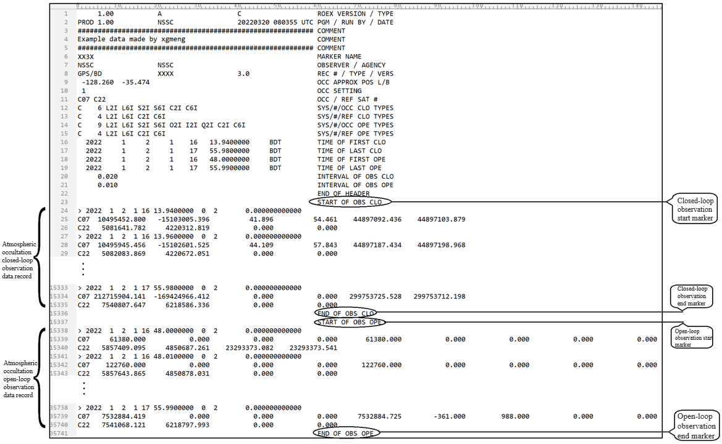

**Fig. 2** Example of the data component of an atmospheric occultation observation data file

### 4.3.2 Observation time

The observation time is the time scale information of the observation in the GNSS atmospheric occultation observation data file. In the data logging section of the GNSS atmospheric occultation observation data file, the observation time should be recorded before each set of observation data.

### 4.3.3 Type of observations

The GNSS atmospheric occultation observation includes the following types,

1. Carrier phase: one of the basic observation quantities in the GNSS atmospheric occultation observation data file, which is used to calculate the additional phase of the GNSS occultation. The carrier phase observations recorded in the GNSS occultation observation data file should be recorded in full weeks (the recorded value may contain fractional parts). The carrier phase half-periods observed by square receivers (for GPS only) should also be converted to full-period records and identified with the corresponding observation code (see 5.2.2).
2. Signal-to-noise ratio: one of the basic observation quantities in the GNSS atmospheric occultation observation data file, reflecting the amplitude information of GNSS occultation observation. The signal-to-noise observations recorded in the GNSS occultation data file should be recorded in units of V/V.
3. Pseudorange: It is recorded in the GNSS atmospheric occultation observation data file as an additional observation quantity. The pseudo-range observations are derived from the time difference between the receiver reception time and the GNSS satellite signal emission time and are mainly used in the occultation processing to calculate the GNSS satellite position at that time by calculating the GNSS satellite signal emission time. The pseudo-range observations recorded in the GNSS occultation observation data file are in meters.
4. Open-loop model phase: one of the basic observation quantities in the GNSS atmospheric occultation data file, used to reconstruct the open-loop carrier phase observations on the ground together with the open-loop IQ. The open-loop model phase observations recorded in the GNSS occultation data file are in units of weeks.
5. Open-loop I-way and open-loop Q-way: one of the basic observation quantities in the GNSS atmospheric occultation observation data file, used to reconstruct the open-loop carrier phase observation quantities on the ground together with the open-loop model phase. The open-loop I-way and open-loop Q-way observations recorded in the GNSS occultation data file are dimensionless.

### 4.3.4 Order of observations

The header record "SYS/#/OCC CLO TYPES" (or "SYS/#/REF CLO TYPES" or "SYS/#/REF OPE TYPES") in the file header section of the GNSS atmospheric occultation observation data file SYS/#/OCC OPE TYPES" or "SYS/#/REF OPE TYPES") is a description of the type of observation in the observation data record of this file. In the data section of the file, all observations for each GNSS satellite for each epoch shall be recorded in the order of the observation code in the corresponding header record.

### 4.3.5 Definition of the data section format

The data section format definitions of the GNSS atmospheric occultation observation data files are shown in Table 5.

**Tab. 5** GNSS atmospheric occultation observation data file - data part format

|  |  |  |
| --- | --- | --- |
| **Record identification (61-80 columns)** | **Descriptions** | **Format** |
| **START OF OBS CLO** | The next line begins with a record of closed-loop observations of atmospheric occultations | A60 |
| **END OF OBS CLO** | Closed-loop observation of atmospheric occultation ends | A60 |
| **START OF OBS OPE** | The next line starts to record open-loop observations for atmospheric occultations | A60 |
| **END OF OBS OPE** | Atmospheric occultation open-loop observation ends | A60 |
| **\* COMMENT** | Comment line | A60 |
| **---** | Epoch records  - Record identifier: ﹥  epoch:  -year (4 digits)  -month, day, hour, minute (2-digits each)  -second  - Epoch symbols:  0: Normal  1: Power outage or power failure between the current epoch and the previous epoch  >1: Incident (The incident situation is shown in Table 6)  - Number of satellites observed in the current year  - (reservation)  - receiver clock bias (unit: s, optional)  - Altitude of occultation tangent point (unit: m, optional) | A1,  1X, I4,  4(1X, I2),  F11.7,  2X, I1,  I3,  6X,  F15.12,  F12.3 |
| **---** | The epoch flag is 0 or 1 to start recording observations as follows:  - Satellite number  - Observations  Example:  C08 328960404.711 -238484692.530 356.471 237.651  For each observation type, the observation will be repeated in the record:  The order of the closed-loop occultation observations is the same as the order of the observation types given in the header record "SYS/#/OCC CLO TYPES";  The order of the closed-loop reference star observations is the same as the order of the observation types given in the header record "SYS/#/REF CLO TYPES";  The order of the open-loop occultation observations is the same as the order of the observation types given in the header record "SYS/#/OCC OPE TYPES";  The order of the open-loop reference star observations is the same as the order of the observation types given in the header record "SYS/#/REF OPE TYPES".  The record is repeated for GNSS satellites where occultations (or as reference satellites) were observed in the current epoch. The length of this record is based on the number of observation types for that type of GNSS satellite.  Missing observations are indicated by 0.0 or a space.  The phase value of the overflow fixed format F14.3 should be adjusted to match the record format (e.g. by adding or subtracting 109). | A1, I2  m(F14.3,2X) |
| **Note**: Data records marked with "*" are optional. | | |

### 4.3.6 Epoch symbols of the data section

The description of ephemeris flag events in the data section of the GNSS atmospheric occultation observation data file is shown in Table 6.

A flag greater than 1 indicates an event. The events with flag 4~5 indicate that header records can be inserted for description, and the value originally used to record the "number of satellites" represents the number of header records to be inserted below, which is 0 when no header records are inserted, and the maximum number of header records that can be inserted is 999. If the event does not contain a calendar record, the area of the calendar record is left blank.

**Tab. 6** Epoch flag incident in the data section

|  |  |
| --- | --- |
| **Epoch flag** | **Incident Description** |
| **2** | Reservation |
| **3** | Reservation |
| **4** | The header record will be inserted later |
| **5** | Other incidents (e.g., temporary insertion of an epoch moment record, which is under the same time system as the observation time) |

# 5 GNSS IONOSPHERIC OCCULTATION OBSERVATION DATA INDEPENDENT EXCHANGE FORMAT FILE

## 5.1 Overview

Each GNSS ionospheric occultation observation data file contains data for a single occultation event observation period only. The header section of the data file describes the global properties of the ionospheric occultation event, and the data section is the observation data record of the ionospheric occultation event.

## 5.2 Document Header Section

### 5.2.1 Components

The header of GNSS ionospheric occultation observation data file consists of several header records from "REX VERSION/TYPE" to "END OF HEADER", and a typical file header composition is shown in Fig. 3.

The observation code in the header record is used to identify the type of observation in the data record in the data section, as defined in 5.2.2, and the correspondence with the observation is defined in 6.3.3.2. The specific format of the header record is defined in 6.2.3.

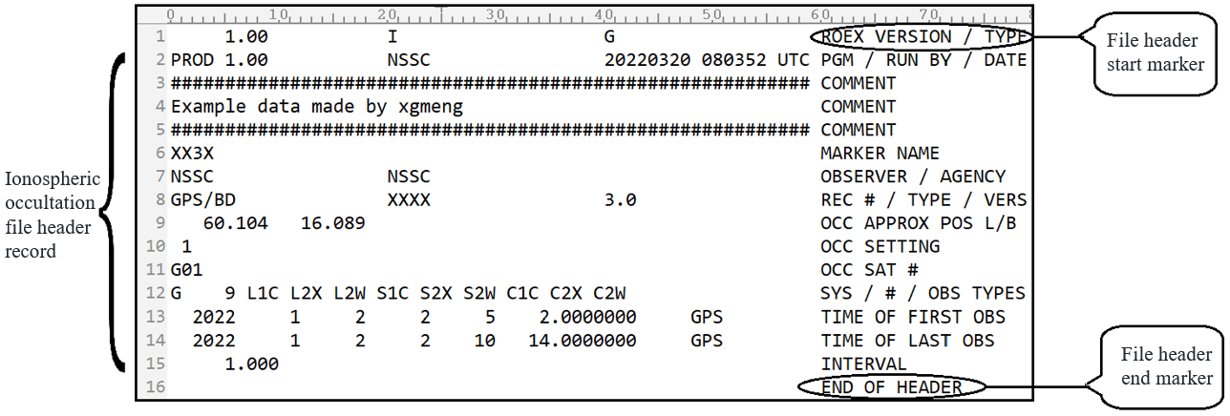

**Fig. 3** Example of the composition of the header section of an ionospheric occultation observation data file

### 5.2.2 Observation Code

The header of the GNSS ionospheric occultation observation data file uses observation codes to identify the different observation quantities and their attributes. The only three types of observations in the GNSS ionospheric occultation observation data file are carrier phase, signal-to-noise ratio, and pseudorange, and their observation codes are the same as defined in 4.2.2.

### 5.2.3 Format of the Header Section

The format of the header section of the GNSS ionospheric occultation observation data file is shown in Table 7.

**Tab. 7** GNSS ionospheric occultation observation data file header format

|  |  |  |
| --- | --- | --- |
| **Header record identification (61-80 columns)** | **Descriptions** | **Format** |
| **ROEX VERSION / TYPE** | - Format Version:1.00  - File Type (“I”: Ionospheric occultation observation data file)  - Satellite System Code:  “C”: BDS  “G”: GPS  “R”: GLONASS  “E”: Galileo  “J”: QZSS  “I”: IRNSS  “S”: SBAS | F9.2,11X,  A1,19X,  A1,19X |
| **\* COMMENT** | Comment line | A60 |
| **MARKER NAME** | Measurement marker point (carrier) name | A60 |
| **OBSERVER / AGENCY** | Name of observer/institution | A20, A40 |
| **REC # / TYPE / VERS** | Receiver number, model, and version  (Version: e.g. version of the receiver's built-in software) | 3A20 |
| **\* OCC APPROX POS L/B** | - Approximate position of ionospheric occultation events, expressed in longitude/latitude  Unit: degree  Coordinate frame suggested for ITRF | 2(1X, F8.3),42X |
| **OCC SETTING** | Ascending or descending occultation flags (0: Ascending;1: descending.) | I2,58X |
| **OCC SAT#** | - Ionospheric occultation satellite system(C/G/E/R/J/S/I)  - Ionospheric occultation satellite number | A1,  I2,57X |
| **SYS / # / OBS TYPES** | - Satellite Systems(C/G/E/R/J/S/I)  - For the different number of observations of this satellite system- Observed quantity descriptors:  Observation type, frequency band, attributes  If there are more than 13 observations: use the continuation solution. | A1,  2X, I3,  13(1X, A3)  6X,13(1X, A3) |
| **\*INTERVAL** | - Observation interval(s) | F10.3 |
| **TIME OF FIRST OBS** | - Time of the first observation record:  Year (4 digits)  Month, day, hour, minute (2 digits each)  Seconds  - Time System:  BDT (=BDS Time System)  GLO (=UTC Time System)  GAL (=Galileo Time System)  GPS (=GPS Time System)  QZS (=QZSS Time System)  IRN (=IRNSS Time System)  Default:  BDS File, Time System BDT  GPS File, Time System GPS  Galileo File, Time System GAL  GLONASS File, Time System GLO  QZSS File, Time System QZS  IRNSS File, Time System为IRN | I6,  4I6,  F13.7,  5X, A3 |
| **\*TIME OF LAST OBS** | - Time of final observation record:  Year (4 digits)  Month, day, hour, minute (2 digits each)  Seconds  - Time System:  Same as the "TIME OF FIRST OBS" record | I6,  4I6,  F13.7,  5X, A3 |
| **\*RCV CLOCK OFFS APPL** | - Whether real-time receiver clock bias correction is performed  1: Yes;0: No; Default: No correction required | I6 |
| **\*LEAP SECONDS** | -leap second (Corresponding system ephemeris broadcast)  -Leap seconds before and after the new leap seconds take effect (instantaneously)  - Week count for new leap seconds to take effect WN_LSF (Continuous weekly count)  - Number of days in the week when the new leap second is in effect DN  0 if unknown or leave blank  Mix file for leap second information for UTC versus BDT | I6,  I6,  I6,  I6 |
| **END OF HEADER** | The last record in the header section | 60X |
| **Note**: Data records marked with "*" are optional. | | |

## 5.3 Data Section

### 5.3.1 Components

The data section of the GNSS ionospheric occultation data file consists of ionospheric occultation observation data records, see Figure 4. ionospheric occultation data records include observation times and corresponding observation quantities.

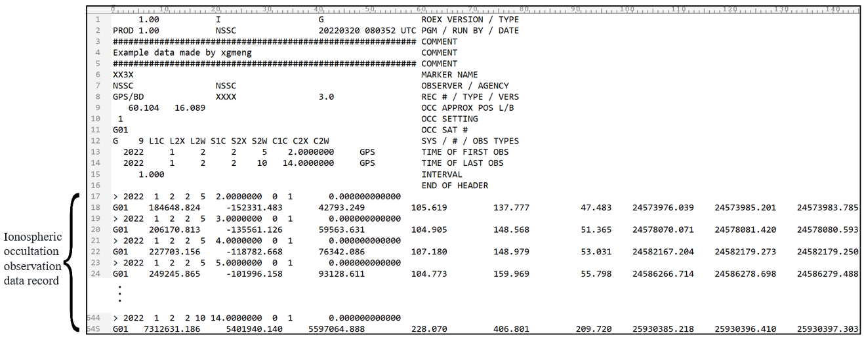

**Fig.4** Example of the data component of the ionospheric occultation observation data file

### 5.3.2 Observation time of the data section

The observation time is the time scale information of the mesoscopic measurements in the data section of the GNSS ionospheric occultation observation data file. In the data logging section of the GNSS ionospheric occultation observation data file, the observation moment should be recorded before each set of observation data.

### 5.3.3 Type of observations

The only three observation quantities in the GNSS ionospheric occultation observation data file are carrier phase, signal-to-noise ratio, and pseudorange, and the meaning of their observation quantities is the same as 5.3.3.

### 5.3.4 Order of Observations

The header record "SYS / # / OBS TYPES" in the header section of the GNSS ionospheric occultation observation data file is a description of the observation data record of the file. The header record should first be labeled with the satellite system identifier, followed by the number of observations observed by that type of satellite and the corresponding list of observation codes. In the data section of the file, all observations for each satellite under each calendar element should be recorded in the order of the list of observation codes in the corresponding header record.

### 5.3.5 Format of the data section

The data section format definitions of the GNSS ionospheric occultation observation data files are shown in Table 8.

**Tab. 8** GNSS ionospheric occultation observation file - data part format

|  |  |  |
| --- | --- | --- |
| **Record identification (61-80 columns)** | **Descriptions** | **Format** |
| **\* COMMENT** | Comment line | A60 |
| **---** | Epoch records  - Record identifier:﹥  epoch:  -year (4 digits)  -month, day, hour, minute (2-digits each)  -second  - Epoch symbols:  0: normal  1: Power outage or power failure between the current epoch and the previous epoch  >1: Incident (The incident situation is shown in Table 6)  - Number of satellites observed in the current year  -(reservation)  - receiver clock bias (unit: s, optional) | A1,  1X, I4,  4(1X, I2),  F11.7,  2X, I1,  I3,  6X,  F15.12 |
| **---** | The epoch flag is 0 or 1 to start recording observations as follows:  - Satellite number  - Observations  Example:  C14 -280917.930 281675.672 260.114 374.822  For each observation type, the observations will be repeated in the record (in the same order as given in the header record "SYS / # / OBS TYPES").  Only one GNSS satellite with ionospheric occultation is observed and recorded in the current ephemeris. The length of this record depends on the number of ionospheric occultation observation types.  Missing observations are indicated by 0.0 or a space.  The phase value of the overflow fixed format F14.3 should be adjusted to match the record format (e.g. by adding or subtracting 109). | A1, I2  m (F14.3, 2X) |
| **Note**: Data records marked with "*" are optional. | | |

# 6 GNSS POSITIONING OBSERVATION DATA INDEPENDENT EXCHANGE FORMAT FILE

For the GNSS positioning observation data independent exchange format file, please refer to the RINEX file description document.

# 7 APPENDIX(informativ)

**Example of GNSS radio occultation sounder data independent exchange format file**

## A.1 Example of BDS atmospheric occultation observation data file

An example of the BDS atmospheric occultation observation data file is shown in Figure A.1.

## A.2 Example of GPS atmospheric occultation observation data file

An example of the GPS atmospheric occultation observation data file is shown in Figure A.2.

## A.3 Example of BDS/GPS hybrid atmospheric occultation observation data file

An example of the BDS/GPS hybrid atmospheric occultation observation data file is shown in Figure A.3.

## A.4 Example of BDS ionospheric occultation observation data file

An example of the BDS ionospheric occultation observation data file is shown in Figure A.4.

## A.5 Example of GPS ionospheric occultation observation data file

An example of the GPS ionospheric occultation observation data file is shown in Figure A.5

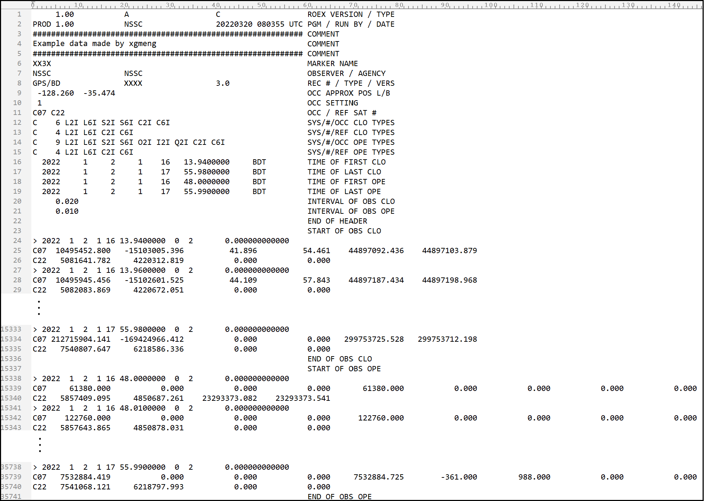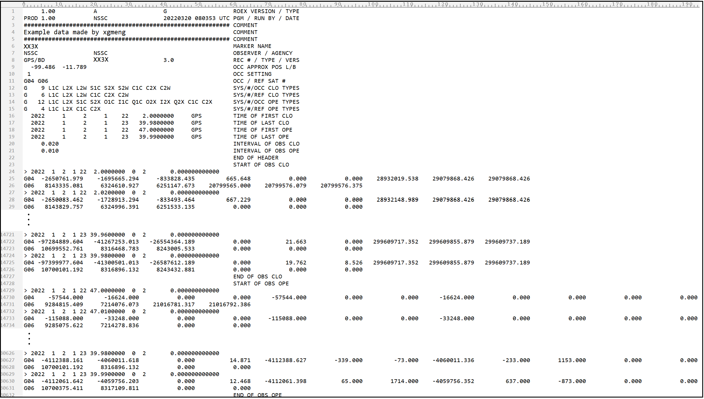

Fig.A.1 Example of BDS atmospheric occultation observation data file

Fig.A.2 Example of GPS atmospheric occultation observation data file

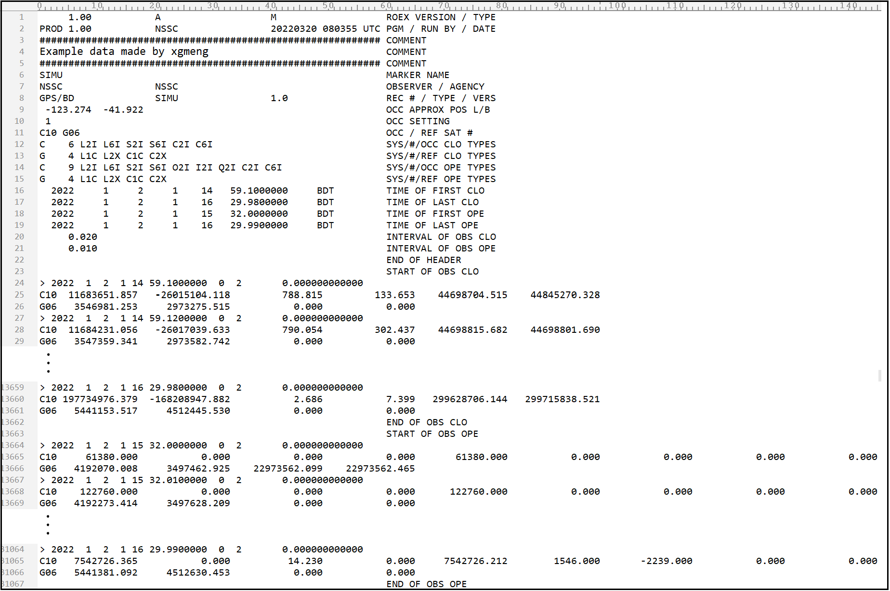

Fig.A.3 Example of BDS/GPS hybrid atmospheric occultation observation data file

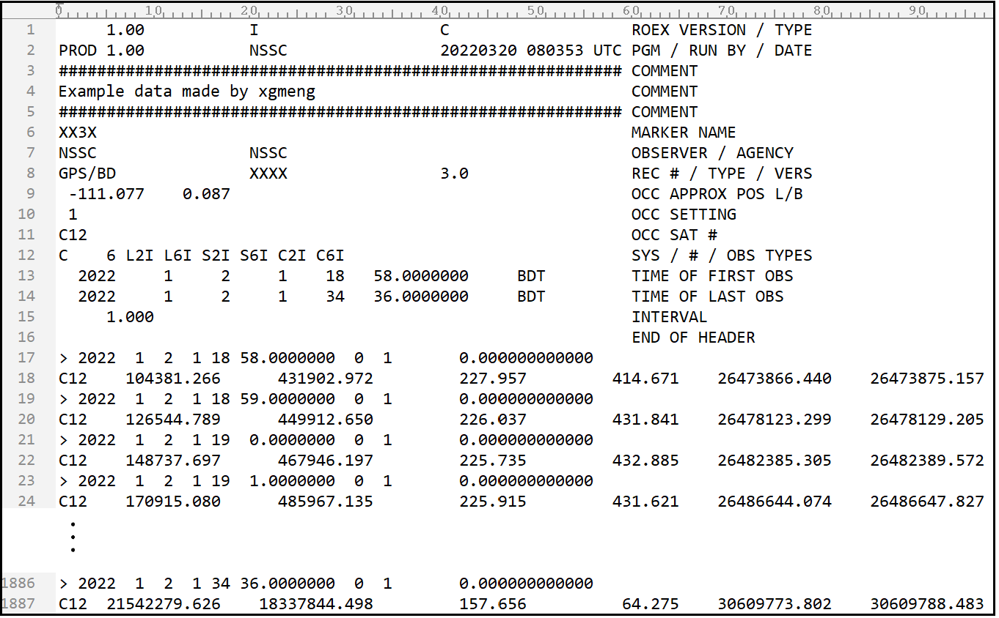

Fig.A.4 Example of BDS ionospheric occultation observation data file

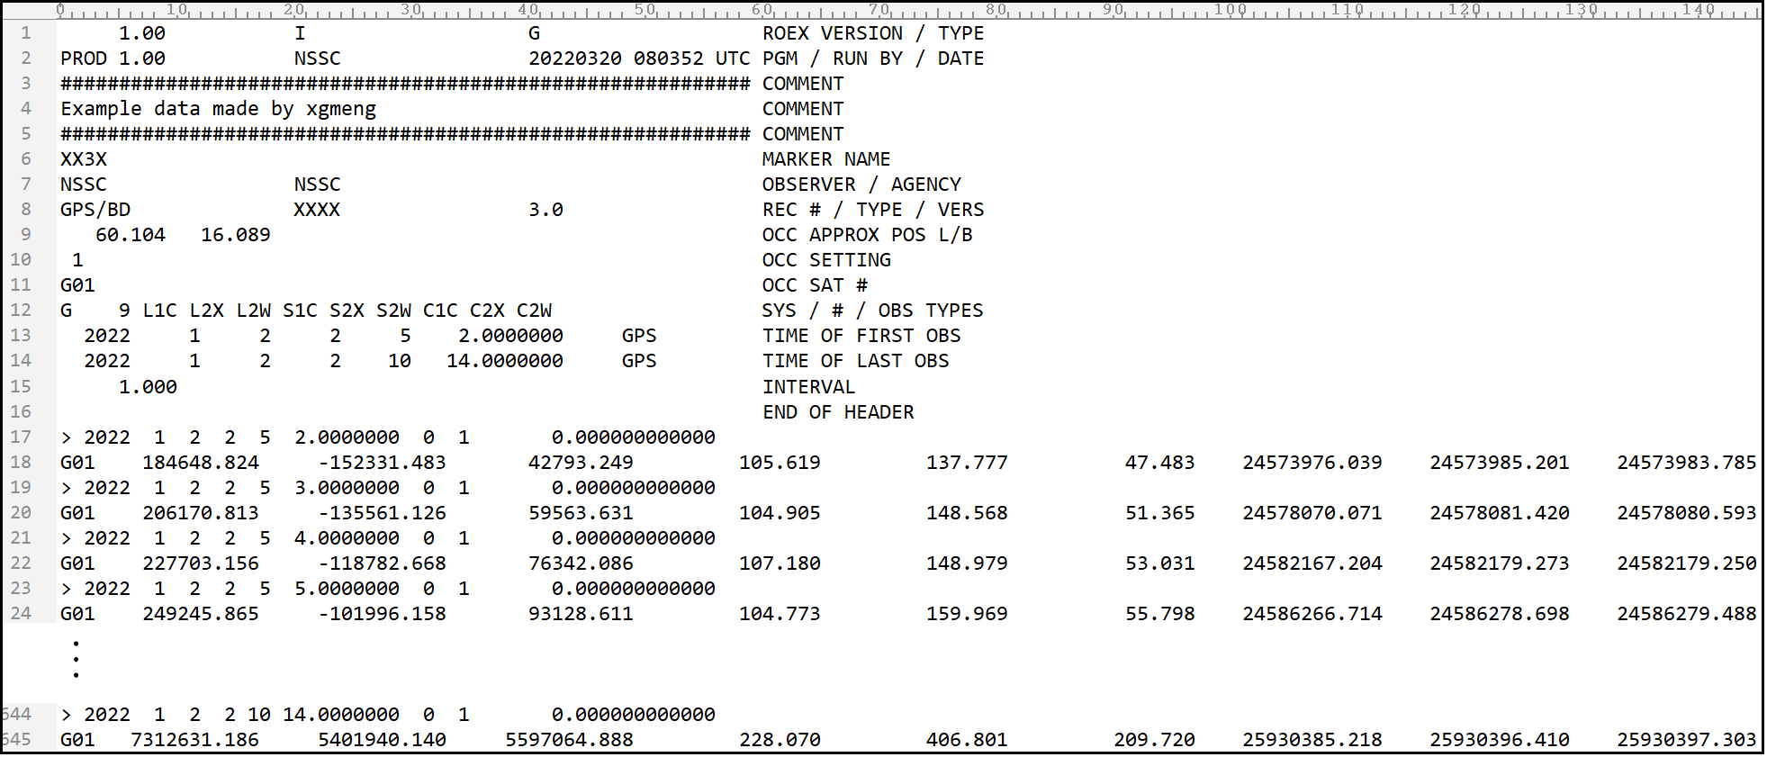

Fig.A.5 Example of GPS ionospheric occultation observation data file



1. 1)Atmospheric occultation observations in this document refer specifically to neutral atmospheric occultation observations.